My Bus Stop CHINA Observations

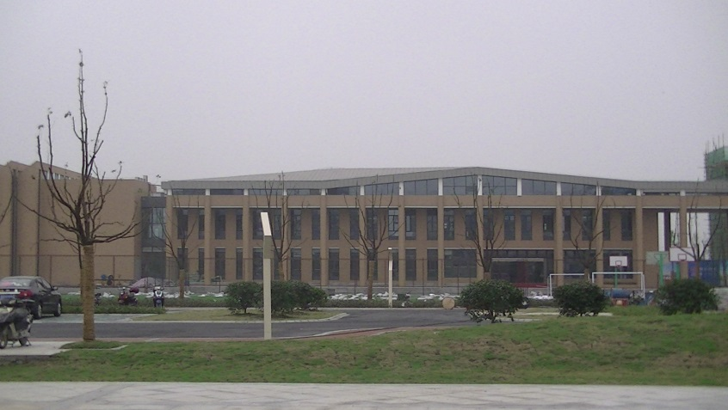
To be honest, before I made my first round of scheduled visits to international schools in China, I didn’t believe my own rhetoric about living and teaching in this country. I had doubts as to whether I could even survive 10 days let alone make several important forays there over the coming months and years. An important market for most industries international education no exception, China definitely warranted most of my attention and it was clear that if I didn’t like it, I was going to have to get to like it or risk all! A private-public partnership with provincial Chinese governments accepting bids from experienced Education companies keen to open and manage schools fueled the international school market in China. Competing fiercely for industrial and manufacturing might Chinese municipalities have with frightening speed opened factories making anything from car parts to home appliances or high tech products in northern Chinese cities such as Shenyang. They vie fiercely to attract foreign expertise and so doing, contrive to offer quality international schooling and Western style amenities to company executives willing to operate in their region. Some of these facilities are astounding; it isn’t unusual to visit a school premises rivaling some of the best in the developed world with a capacity for upwards of 2,000 students educating a humble enrollment of less than 100 students. It’s a waiting game where the stakes are high, but it’s a gamble that will no doubt pay off, as China’s economy continues to perform well both in local and international markets.
1 Facilities can be astounding!
Much of what troubled me about China before even making a footprint on its soil proved mistaken. I met with only kindness and politeness from young and old, transport infrastructures in the main cities were surprisingly well developed; taxis, trains and airlines clean, efficient and remarkably straightforward and honest. High-end to mid-range Hotels, restaurants and shops are on a par with those in leading global cities and entertainment and sporting amenities both available and often state of the art. It helped China enormously to have hosted a summer Olympics and International Expo; young people embraced their ambassador role and I found it almost impossible to get lost anywhere in Beijing, Shanghai or Guangzhou where even the subtlest look of unease brought on a wave of concerned locals all eager to shepherd me in the right direction.

You will get out of it what you put in
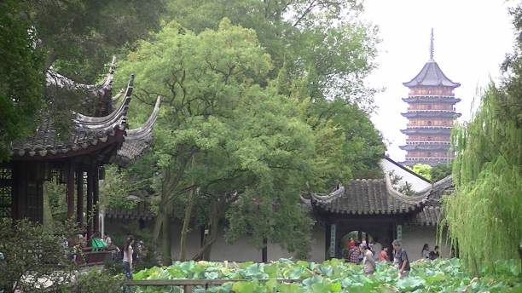
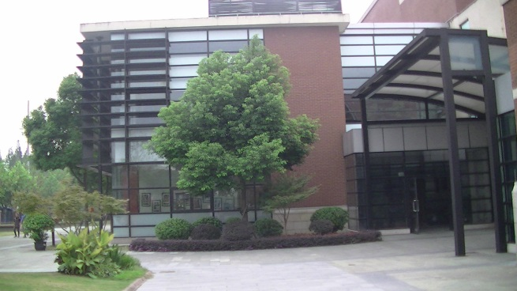
Over the course of the past two years I have travelled to 17 different Chinese cities from the populous, warm southern provinces to the cold northern regions bordering on Russia and North Korea. A ‘small’ city in China can number six million people but where there is a Western foreign work force, you’re bound to stumble on an Irish pub or two, movie theatres showing English language movies, informal soccer or rugby competitions and definitely a Hash-House Harrier club. There’s opportunity too, to enjoy the company of Chinese friends who will readily be your guide, invite you to their homes and offer to help you speak their language. Like any overseas teaching experience, you will get out of it what you put in. I recall a conversation with a young female teacher in Changchun who despite the long, cold Winter months where temperatures fall well below freezing made an effort to make it to the gym, go out to restaurants to eat with friends or attend ice-sculpture exhibitions. “You could easily just hibernate in your warm apartment all winter and become very lonely and depressed”, she said. Making the decision to live and work in a city with a challenging climate forces you to dig deep and reach out to colleagues, and the local community.
2 Beautiful gardens in Suzhou
International School offerings in China vary greatly. They cater for a diverse range of foreign workers and depending on their status can also enroll a percentage of Chinese nationals. However, many Chinese students enrolled in private schools tend to hold a second passport and/or to have lived sometime overseas. A compliment of A list schools centered predominantly in Shanghai, Beijing and Guangzhou offer programmes and facilities that would rival (and perhaps exceed) their private school counterparts in the US and UK. Frighteningly expensive and academically oriented, graduates typically go on to attend the top universities across the globe. There’s a plethora of schools opened in the past 10 years with some serious branding; I’m told by one Head teacher fees are similar to what you would expect to pay for a top Boston boarding school! We’re talking serious money here. Outstanding facilities and impressive graduating classes add to the unequivocal scholastic tone; standards are high while expectations are even higher with graduates heading to the ‘Who’s Who’ of esteemed higher learning institutions no matter what country in selected.
3 A list schools with facilities that would rival private school counterparts the US and UK.

If I’m over embellishing the China experience, I don’t mean to be.
It’s true, I haven’t actually lived in this country and my visits have been no longer than 3 weeks at a time. I imagine an extending living and working experience may take the gloss off in some respects but my visits did leave me with the perception what I COULD live there and that was a revelation to me.
It has to be said that moving about in the lesser known cities can be somewhat fraught if you’re not meticulously well planned. My first port of call when entering a hotel is the concierge desk where I hand over a number of addresses for translating from English to Mandarin in big, bold characters as taxi drivers routinely speak no English. I’m forever grateful that I don’t receive a rebuff from busy hotel staff when explaining the task, instead I’m always met with courtesy and staff members who go out of their way to accommodate my wishes.
If telecom roaming costs are exorbitant its very handy to have a Chinese sim card inserted on arrival at the airport; I can’t remember how many times I resorted to phoning the receptionist at a school and handing the cell phone over to the driver. Once again, politeness is the rule of thumb as on many occasions taxi drivers would be within their right to place me firmly on the sidewalk so vague are my instructions but they never did and in hundreds of taxi rides I only ever came across two drivers whose reactions made me a little uncomfortable.
Do I also need to mention carting luggage up and down flights of stairs getting to and from railway stations and trains? There are escalators but it took me awhile to work this out and on that first occasion, you guessed it, it was out of service Needless to say, after the first trip to China the weight of my bag was a real consideration. It’s very difficult for me to travel without everything bar the kitchen sink so packing for subsequent trips was actually the most troublesome planning I had to do.
In cities such as Suzhou and Changchun, I’ve heard it said that supermarket shopping is forever revered as the typical experience is finding essential items in not two but likely three, four or five locations. The weekly shopping can be an arduous and time consuming task, particularly if you have little ones in tow, but it’s definitely never dull! Here’s where your seasoned colleagues come in handy and where the Orientation Guide your school staff has contributed to, becomes hugely helpful. A mentor teacher assigned prior to you arriving in the city can prepare you well for what you might expect and having them available to take you shopping to all the ‘must know’ stores saves angst and time.
I won’t be back in China for a few months, but truthfully, I miss my trips there and will genuinely look forward to returning. The country is so huge and there’s so much to explore that even having visited 17 cities to date, I haven’t even scratched the surface. With countless numbers of Chinese tourists seeking overseas holiday destinations and China accepting vast numbers of tourists to its own country, the China of old draped in mystique and quite frankly miscast in one stereotype after another, is definitely long gone. Personally, I’m perfectly comfortable moving about this vast country and that says a great deal as I’m no spring chicken; if I can manage it, you can to and I urge you to do so!

